Project Planning Phase

**Project Planning Template (Product Backlog, Sprint Planning, Stories, Story points)**

|  |  |
| --- | --- |
| Date | 8 November 2022 |
| Team ID | PNT2022TMID21860 |
| Project Name | Fertilizer Recommendation System for Disease  Prediction |
| Maximum Marks | 8 Marks |

Product Backlog, Sprint Schedule, and Estimation (4 Marks)

|  |  |  |  |  |  |  |
| --- | --- | --- | --- | --- | --- | --- |
| **Sprint** | **Functional**  **Requirement (Epic)** | **User Story Number** | **User Story / Task** | **Story**  **Points (Total)** | **Priority** | **Team Members** |
| Sprint-1 | Model Creation and Training (Fruits) |  | Create a model which can classify diseased fruit plants from given images. I also need to test the  model and deploy it on IBM Cloud | 8 | High | Vignesh Tamilselvan  Udhayaraj  Vasanthakumar |
|  | Model Creation and Training (Vegetables) |  | Create a model which can classify diseased vegetable plants from given images | 2 | High | Vignesh Tamilselvan  Udhayaraj  Vasanthakumar |

|  |  |  |  |  |  |  |
| --- | --- | --- | --- | --- | --- | --- |
| **Sprint** | **Functional Requirement**  **(Epic)** | **User Story Number** | **User Story / Task** | **Story Points**  **(Total)** | **Priority** | **Team Members** |

|  |  |  |  |  |  |  |
| --- | --- | --- | --- | --- | --- | --- |
| Sprint-2 | Model Creation and Training (Vegetables) |  | Create a model which can classify diseased vegetable plants from given images and train on IBM Cloud | 6 | High | Vignesh Tamilselvan  Udhayaraj  Vasanthakumar |
|  | Registration | USN-1 | As a user, I can register by entering my email, password, and confirming my password or via OAuth API | 3 | Medium | Vignesh Tamilselvan  Udhayaraj  Vasanthakumar |
|  | Upload page | USN-2 | As a user, I will be redirected to a page where I can upload my pictures of crops | 4 | High | Vignesh Tamilselvan  Udhayaraj  Vasanthakumar |
|  | Suggestion results | USN-3 | As a user, I can view the results and then obtain the suggestions provided by the ML model | 4 | High | Vignesh Tamilselvan  Udhayaraj  Vasanthakumar |
|  | Base Flask App |  | A base Flask web app must be created as an interface for the ML model | 2 | High | Vignesh Tamilselvan  Udhayaraj  Vasanthakumar |
| Sprint-3 | Login | USN-4 | As a user/admin/shopkeeper, I can log into the application by entering email & password | 2 | High | Vignesh Tamilselvan  Udhayaraj  Vasanthakumar |
|  | User Dashboard | USN-5 | As a user, I can view the previous results and history | 3 | Medium | Vignesh Tamilselvan  Udhayaraj  Vasanthakumar |
|  | Integration |  | Integrate Flask, CNN model with Cloudant DB | 5 | Medium | Vignesh Tamilselvan  Udhayaraj  Vasanthakumar |
|  | Containerization |  | Containerize Flask app using Docker | 2 | Low | Vignesh Tamilselvan  Udhayaraj  Vasanthakumar |
|  |  |  |  |  |  | . |

|  |  |  |  |  |  |  |
| --- | --- | --- | --- | --- | --- | --- |
| Sprint-4 | Dashboard (Admin) | USN-6 | As an admin, I can view other user details and uploads for other purposes | 2 | Medium | Vignesh Tamilselvan  Udhayaraj  Vasanthakumar |
|  | Dashboard (Shopkeeper) | USN-7 | As a shopkeeper, I can enter fertilizer products and then update the details if any | 2 | Low | Vignesh Tamilselvan  Udhayaraj  Vasanthakumar |
|  | Containerization |  | Create and deploy Helm charts using Docker Image made before | 2 | Low | Vignesh Tamilselvan  Udhayaraj  Vasanthakumar |

Project Tracker, Velocity & Burndown Chart: (4 Marks)

|  |  |  |  |  |  |  |
| --- | --- | --- | --- | --- | --- | --- |
| **Sprint** | **Total Story Points** | **Duration** | **Sprint Start Date** | **Sprint End Date (Planned)** | **Story Points Completed (as on**  **Planned End Date)** | **Sprint Release Date (Actual)** |
| Sprint-1 | 10 | 6 Days | 24 Oct 2022 | 29 Oct 2022 | 10 | 7 nov 2022 |
| Sprint-2 | 15 | 6 Days | 31 Oct 2022 | 05 Nov 2022 | 15 | 7 Nov 2022 |
| Sprint-3 | 15 | 6 Days | 07 Nov 2022 | 12 Nov 2022 | 15 | 13 Nov 2022 |
| Sprint-4 | 12 | 6 Days | 14 Nov 2022 | 19 Nov 2022 | 10 | 15 Nov 2022 |

***NOTE: Burndown charts, Velocity to be updated dynamically after end of sprints* Roadmap:**

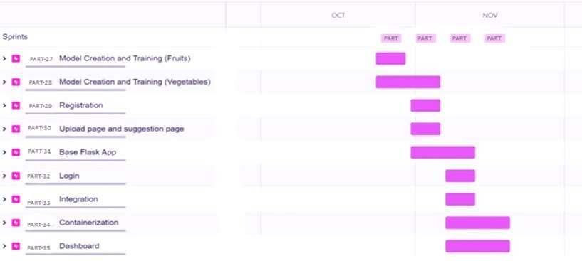

Screenshots:

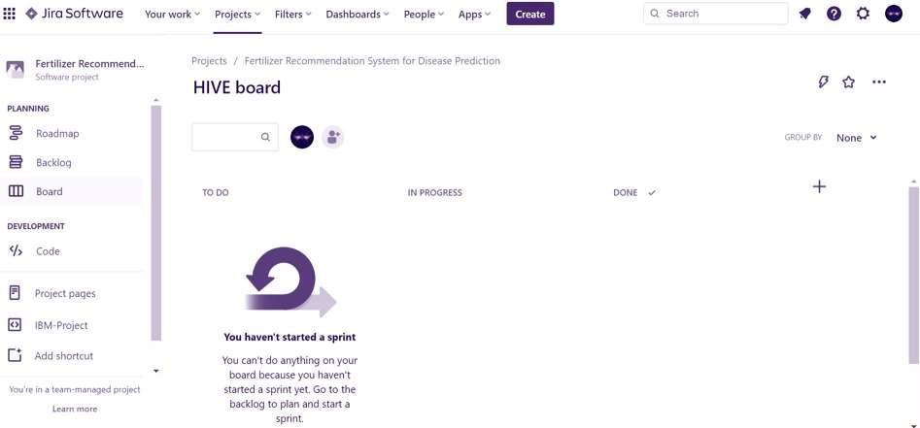

**PART Board**

